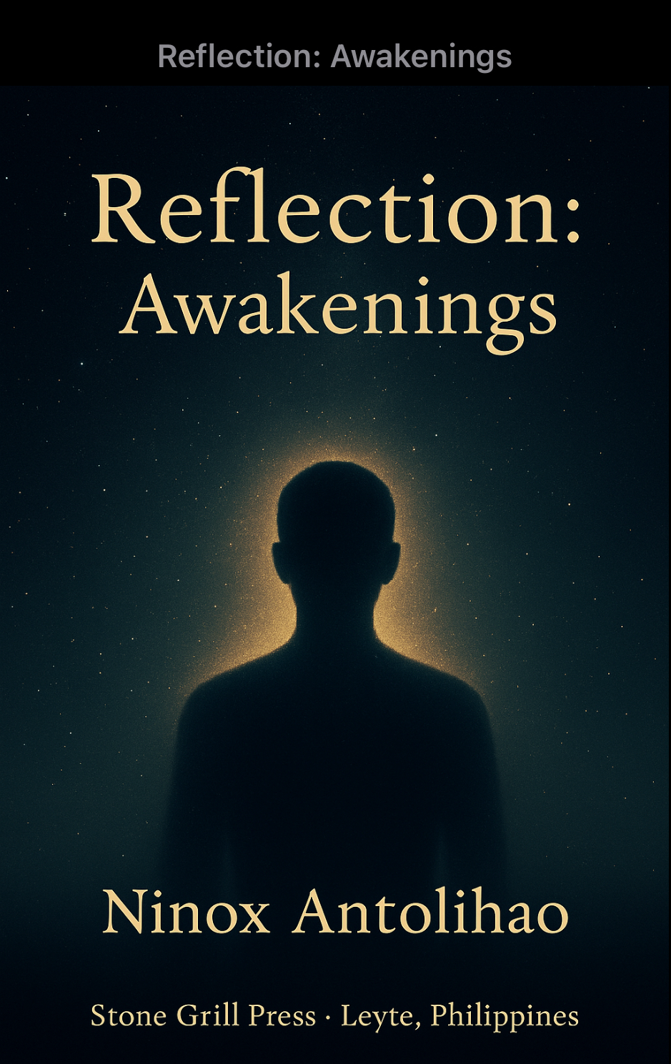
The Triune Reflection
The Eternal Frequency of The Soul
ninox antolihao | 10/7/25 | Awakening

Introduction

There comes a point in every life when belief alone is not enough.
When the words we were taught to repeat no longer echo truth, and we start to ask the questions we were told not to. It is in that quiet rebellion of the soul where awakening begins.
This book is not written to convince or convert. It is written to remember.
To remember that truth is not owned by temples or titles — it lives within every being who dares to seek it. Doubt, in its purest form, is the doorway to understanding.
These reflections are born from silence, curiosity, and the search for meaning. They are not commandments, but mirrors; not doctrines, but sparks. Each chapter explores the tension between mind and spirit, faith and reason, shadow and light — the eternal conversation within the human heart.
If you have ever felt torn between what you were taught and what you feel to be true, may these words remind you:
Truth is not found by standing still in certainty, but by walking humbly through mystery.
“Truth is not revealed to those who wait for light, but to those who dare to walk through the shadows to find it.”

The Courage to Seek Truth

“Not believing their story is not blasphemy — it is the courage to seek truth.”

Faith often begins as inheritance — passed from voices we trust, repeated until it feels like our own. We grow up surrounded by doctrines that promise heaven if followed and damnation if questioned. But true faith, like true courage, does not fear the question why.

Doubt is not rebellion; it is the seed of real understanding. Real faith doesn’t forbid questioning; it survives it. To ask for truth is not betrayal, it’s respect. The mind that seeks with honesty honors the Creator more than the lips that repeat without knowing.

“Questioning does not destroy faith; it purifies it — burning away what was never real.”

The Bargain of Faith

“When belief is traded for reward, it stops being faith and starts being a bargain.”
True faith is born from love, not from fear or the promise of reward. When the purpose of belief becomes the prize, it ceases to be devotion and becomes transaction.
Faith that seeks comfort is fragile; faith that seeks truth is eternal. The moment belief is traded for gain, it loses its soul.
“When belief becomes a trade, it loses its soul.”

The Price of Salvation

“Trading free will for salvation is not faith — it is surrendering truth for security.”

Many surrender thought in exchange for belonging. But salvation without freedom is slavery in disguise. God gave the mind not as a cage, but as a compass. Faith that forbids thought is not divine; it is fear wrapped in ritual.

“Real salvation begins when you dare to think, not when you stop.”

The State of Christ

“Christ is not only a name in history, but a state of being — the vibration of love alive within us.”
Christ is not distant. He is consciousness — the pattern of love that moves through every soul willing to reflect it. To follow Christ is not to imitate His story, but to awaken His essence within.
“Christ is not vibrating into higher consciousness — He is that consciousness, and we rise when we align with Him.”

Mind and Spirit

“The mind is a fine servant but a poor master. When emotion rules, wisdom fades — when ego leads, truth hides.”

The mind is a gift, yet it is also a maze. It builds order out of chaos and becomes lost in its own walls. Intelligence alone cannot see truth. The mind analyzes and divides; the spirit feels unity beneath it all.

When the mind grows loud, it drowns the whisper of the soul. That whisper — what some call the Holy Spirit — is not a voice above us, but a presence within. Plato’s cave, the illusions of the Matrix, and the echoes of religion all point to the same truth: that reality is layered, and awakening is learning to see beyond shadows.

The ego, however, resists. It feeds on recognition and control. It says “I am right, I am separate.” Yet the more it tightens its grip, the further we drift from peace. Ego wants victory; spirit wants truth.

To be awake is not to silence the mind but to let it serve the heart. When emotion and reason bow to awareness, the soul becomes clear — reflecting truth without distortion.

“When the mind kneels before spirit, thought becomes light, and knowing becomes peace.”

The Brightness of Light

“Too much knowledge can be dangerous. We often mistake it for wisdom, yet even King Solomon fell by the weight of his own understanding. Light allows us to see the darkness of the world — but when it becomes too bright, it blinds us.”

Knowledge is a gift, but like fire, it demands respect. It can warm the heart or burn the soul. We reach for light believing it frees us, but when it comes without humility, it blinds.

Even light must rest in darkness to keep its power. Wisdom is light guided by love, and humility is the shade that keeps it bearable.

“Wisdom is not found in endless light, but in learning when to let the light rest.”

When the Cosmos Plants Seeds

“Perhaps the comets are not wanderers, but gardeners — carrying the dust of life across the endless dark, planting what may bloom when the time is right.”
Every comet is a messenger carrying frozen potential. 3I/ATLAS may not bring life to Mars, but it may bring memory — water, carbon, and hope. The cosmos does not create life all at once; it plants it patiently, waiting for the right moment.
We are, in truth, the flowers of a cosmic garden — our roots buried in starlight, our petals reaching for meaning.
“The cosmos does not create life all at once — it plants it, quietly, and waits for it to bloom.”

What Is God?

Disclaimer: These thoughts are my personal reflection and understanding. I share them with respect, not as absolute truth. I encourage everyone to explore, question, and discover what resonates in their own heart.

This is not the God who gives free will but predestines, who is said to be everywhere yet can abandon you, who loves all but hates some, forgives freely yet demands strict judgment, is merciful yet wrathful, brings peace but also war, never changes yet changes His mind, is visible yet invisible, creates everything but not the devil, is all-knowing yet writes our sins, has a plan yet still decides who enters heaven, sacrifices His Son to save us yet still requires faith for salvation.
These contradictions reveal not God’s weakness but our misunderstanding. We shaped Him in our image, giving the Infinite our own conflicts.
We are all sons and daughters of God. Just as cells form tissues and tissues form organs, humanity forms societies — all within one vast body: the universe, which is God. To harm ourselves or others is to wound the universe. To love is to heal God.
God experiences through us. What we feel, God feels. The universe is God unfolding — every star, tree, and heartbeat an expression of the same light.
White light holds every color; when it passes through a prism, its hidden beauty appears. So it is with us: one Source, many forms. We are not separate from God — we are the colors of His light.
Science and spirit now touch hands. The “God particle,” quantum fields, and scripture whisper the same truth: the kingdom of God is within. The universe is not apart from its Source; it is the Source revealing itself.
It is time to step beyond fear and doctrine — to live as conscious extensions of the Divine. To see holiness not in rituals, but in every breath, every atom, every act of kindness.

“We do not search for God beyond the stars; we awaken to God shining through ourselves.”

Collected Reflections

Faith and Truth
- “Not believing their story is not blasphemy — it is the courage to seek truth.”
- “When belief is traded for reward, it stops being faith and starts being a bargain.”
- “Trading free will for salvation is not faith — it is surrendering truth for security.”
- “Faith that cannot face a question is not faith — it is fear in disguise.”

Mind and Emotion
- “Emotions don’t make you less intelligent — losing control of them does.”
- “Even light can blind when it’s too bright — emotion must serve truth, not rule it.”
- “Critical thinking is born in the space between feeling and reacting.”

Light and Knowledge
- “Too much knowledge can be dangerous.”
- “Wisdom is not found in endless light, but in learning when to let the light rest.”

Cosmos and Awakening
- “The cosmos does not create life all at once — it plants it quietly and waits for it to bloom.”

About the Author

Ninox Antolihao is a Filipino thinker known for blending philosophy, spirituality, and science into reflections that awaken inner understanding.

Born with a curious mind and a compassionate soul, Ninox explores the unseen connections between energy, faith, and consciousness—the silent threads that weave all life into one field of being.

He writes not to preach, but to question; not to convert, but to awaken. His works invite readers to look beyond belief and fear and rediscover the truth that every soul is a fragment of the same eternal source.

Outside his writings, Ninox is a community builder and creative entrepreneur. He runs Stone Grill Restaurant in Leyte, Philippines—a space that reflects his philosophy of warmth, unity, and connection. For him, both food and spirit share the same purpose: to nourish, to gather, and to remind us that we belong.

His reflections bridge worlds—faith and logic, science and spirit, matter and mystery—guided by one belief:

Awareness is the light through which humanity evolves.

“I don’t write to teach,” he says.
“I write to remember—and to help others remember too.”

Publisher Imprint
Stone Grill Press · Leyte, Philippines · © 2025 Ninox Antolihao

